**CHAPTER 4: FUZZY LOGIC**

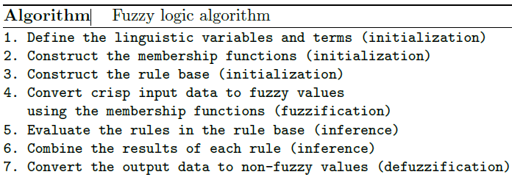

You have to develop a fuzzy logic system for intelligence speed control system for a car. The inputs of your system is the ambience temperature which taken form the car sensors, and cloud cover data taken weather data server. Your system should suggest the driver what is the appropriate speed base on the inputs.

Step 1 (as algorithm above)

To determine the linguistic function its require an expert on particular field to set the appropriate terms to represent the variables and terms. For example, the ambiance temperature is represented as Temp below and the linguistic terms for the Temp divided into 4 categories namely Freezing (eg. temperature from 0 degree F to 30 degree F), Cool, Warm and Hot.

As a human we used term to represent the condition such “*That boy is tall*” we do not used “*The boy height is 170cm*” or “*Watch out for the hot water*” not “*Watch out for the 100 degree C water*” we used term to represent the situation where in fuzzy system it’s called linguistic terms.

For step 1 the expert had propose to you to use these terms:-

Temp: {Freezing(0-30), Cool(30-60), Warm(60-80), Hot(80-100)}

Cover:{Sunny(0-30), Partly Cloudy(30-70), Overcast(80-100)}

Speed:{Slow(0-50), Fast(50-100)}

Step 2

The membership functions constructed using the linguistic term above: -

Let do the first variable Temp, we start with Freezing,

(refer to my explanation and write it down)

Next we do the Cool, Warm and Hot

Finally, we combine each of these into the Temp variables to represent the fuzzy set for that variables.

Next complete the other two variables namely Sunny and Speed.

Then construct the fuzzy membership function as example below: -

 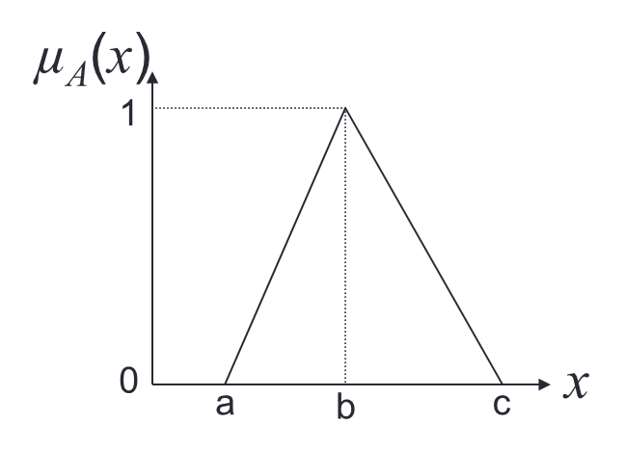

Or

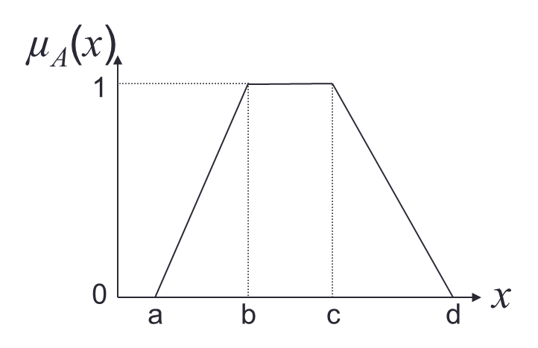

Step 3

For our problem the rules are given as below:-

* If it's Sunny and Cool, drive Fast
* If it's Sunny and Hot, drive Fast
* If it's Cloudy and Warm, drive Slow
* If it's Cloudy and Cool, drive Slow

Example of fuzzy rules No. 1 can be constructed as below: -

Cover(Sunny) ˄ Temp(Cool) => Speed (Fast)

As a normal predicate logic statement (eg. Your IF statement in programming follows the same concept)

Complete the other 3 rules.

Step 4: Fuzzification

Using fuzzy set generated from 1st tutorial, we can get the fuzzy value by putting the crisp value to our membership functions.

Eg: Temp = 27

In this function the value 27 is in Freezing and in the second statement where not on the first statement.

Then we going to use the second formula and input the value.

Eg:

Then for Temp = 27, the fuzzy value is Freezing = 0.3

For our problem you have to produce the fuzzy value for:

**Temp = 81** and **Cover = 23**

Step 5: Rules Evaluation

In rules evaluation we select the rules which the linguistic terms exist in our fuzzification process.

Eg:

Freezing (example above) and we compared to our 4 rules and it does have any Freezing terms then we does not meet any rules. Then the value Temp 27 does not meet any rules.

Check example in slide and select appropriate rules that meet your fuzzy values.

Step 6: Rules Inference (& aggregation of output)

In rules inference we put the value in the rules we selected above and get the output aggregation

Eg:

We have Hot = 0.55 and Sunny = 0.85

If the rules

* If it's Sunny **and** Hot, drive Fast

Sunny(Cover)∧Hot(Temp)⇒Fast(Speed)

**0.85 ∧ 0.55 = 0.55**  ⇒ **Fast = 0.55 (**minimum value between the two attributes)

* If it's Sunny **or** Hot, drive Fast

Sunny(Cover) ˅ Hot(Temp)⇒Fast(Speed)

**0.85 ˅ 0.55 = 0.55**  ⇒ **Fast = 0.85 (**maximum value between the two attributes)

And lastly we combine each output for next step

Eg:

2 rules evaluation with Fast = 0.55, and Fast=0.25

Step 7: Defuzzification

We now refer to the fuzzy output sets and determine the defuzzification value

Eg:

We calculate using COG in slide Module 3 Fuzzy Logic ES.pdf at KALAM slide page 15-17